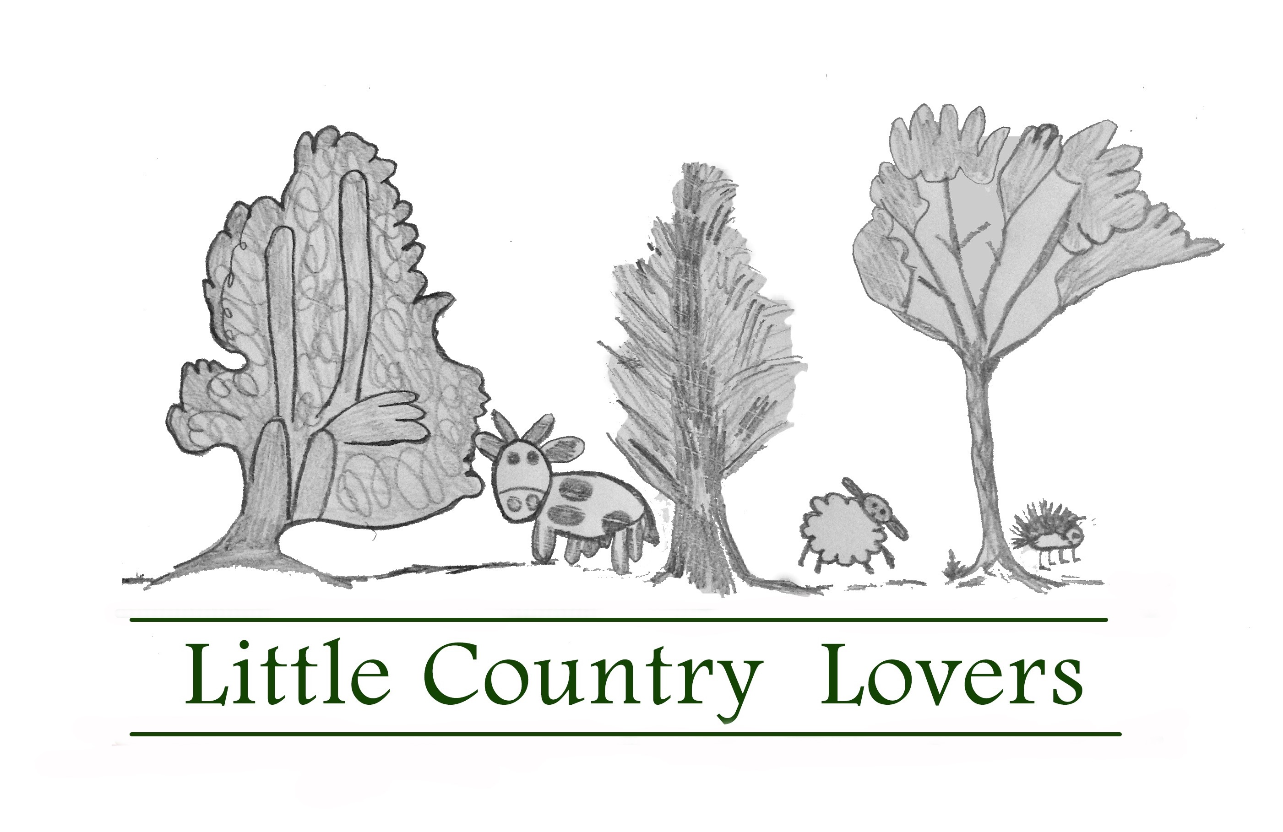
BOOKING REQUEST FORM
Name of child:
D.O.B:
Current school Year:
(Please note Ofsted classes a child to be in their current school year until 1st September)
Name of parent:
Contact Number:
Email:
Dates requesting to book:
Breakfast club: Yes/No
We are Ofsted registered for children in school years 1-6 ONLY
If spaces are available you will receive and invoice and the place will be reserved for 48hrs. Once we have received your BACS payment you will receive a booking confirmation email.
We accept childcare vouchers and tax-free childcare payments. All payments are non-refundable and we are unable to swap places.
If your child is unwell and unable to attend we will offer a short-term credit note, subject to us filling the place.
Due to staffing limitations (and the specific safety challenges of a working farm) if your child receives 1:1 support at school you will need to provide an accompanying adult for the day. If your child has any other particular needs, do please let us know so that these can be discussed with our Manager, Jane prior to booking so that we can make sure everyone gets the most out of their day
FEES (UPDATED 2023)
One day 9am-4pm £38
Two consecutive days £69
Tuesday-Thursday £100 (where applicable)
Breakfast club 8-9am £5.50
10% sibling discount (If booking for a family the first child pays full price with a 10% discount for all siblings)

